# Family details of Mr. Lhakpa Dhondup

|  |  |  |
| --- | --- | --- |
| Children of Lhakpa Dhondup | Status | Employment status, Address |
| Sonam | Wife | Late |
| Migmar Bhuti | Eldest sister | Cleaning and maintenance of school, Tibet |
| Phurbu Wangdue | Eldest brother | Farmer cum running small general store |
| Buchung Dhondup | Elder brother | Immigrated to France |
| Lhakpa Wangyal | Fourth child | Teacher, SBPS School, Dehradun, India |
| Sonam Tsamchoe | Younger sister | Teacher, Tibet |
| Shelok | Younger brother | Handicapped, Tibet |
| Ngawang Sonam | Younger brother | Driver, Tibet |

# Pedigree of Lhakpa Dhondup’s family

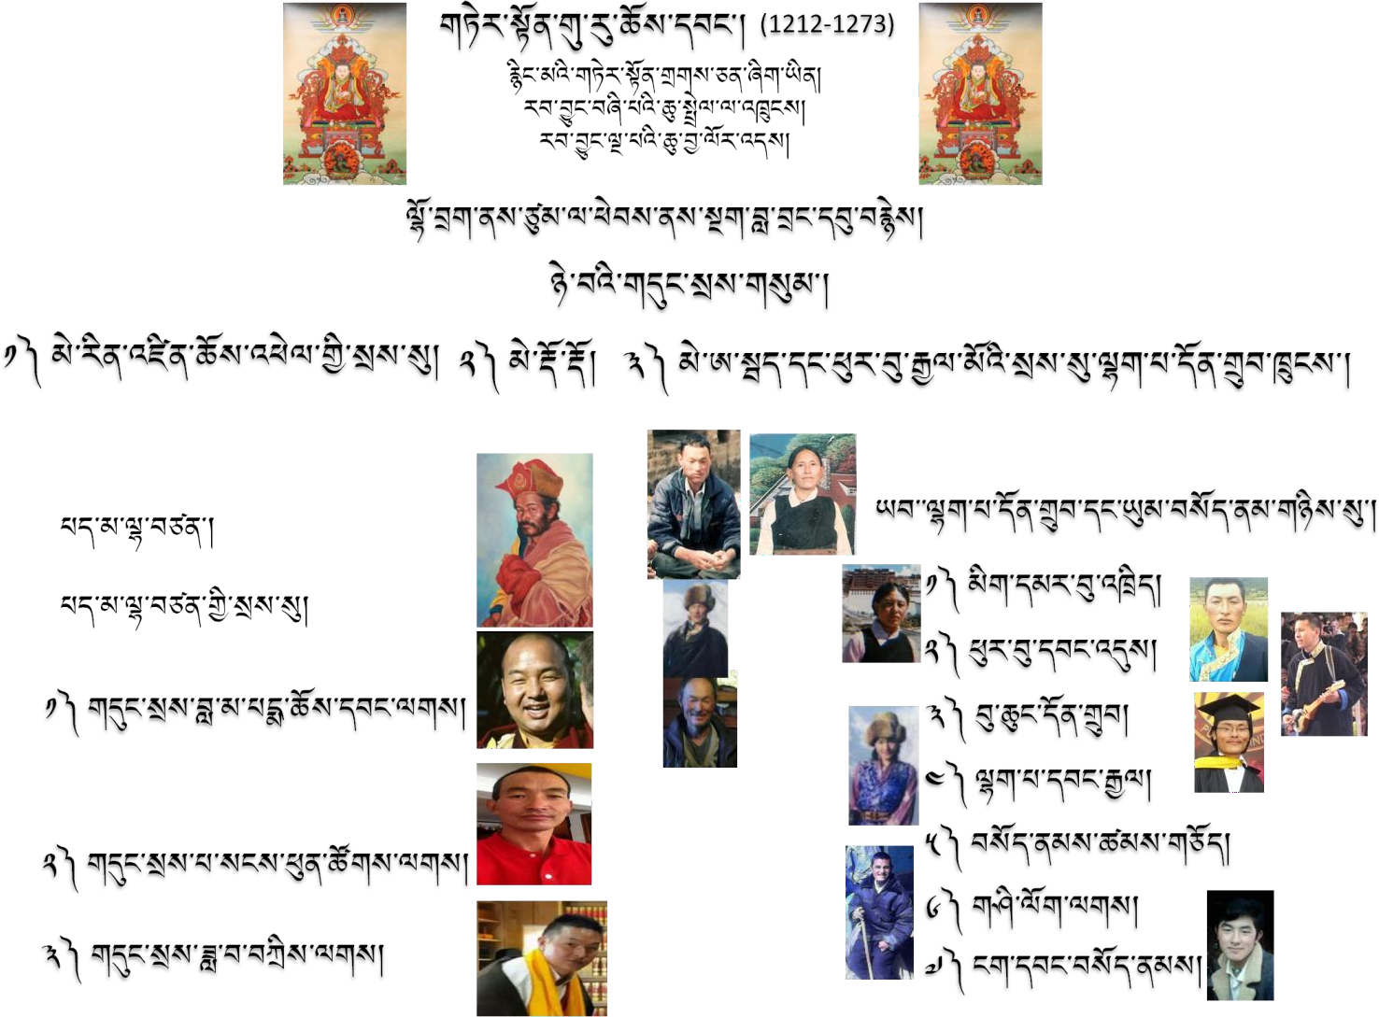

**Brief Biography of Lhakpa Dhondup**

Lhakpa Dhondup is one of the son of Mai Abey (མེ་ཨ་སྦེད།) from Ngak Labrang *-the linage of great thirteenth century Nyingma master Guru Chowang*. The present seat of Ngak Labrang is located near the Border of Tibet and China at Tsum Nubri, Nepal. Lhakpa Dhondup learnt Tibetan language and Tibetan Buddhism from his ancestors. He had been patriotic and loyalty towards Tibet and His holiness the XIV Dalai Lama. His persistent patriotism for the cause of Tibet made him engage in socio-political activities in 1970s. In year 1976, he was arrested and imprisoned secretly without any warning and knowledge of my family members. Later, his imprisonment was known to the family and it was due to distribution and exchange of political letters among Tibetan activists inside and out of Tibet. The political letters were themed mainly about Chinese activities in the localities of Kyidrong, particularly about demolition of ancient religious sites and temples. He was imprisoned for **five years at Shigatse prison** from years 1976 to 1980and was moved to Drapchi prison, in which he was imprisoned for five more years from 1980 to 1985. During those years, his family members had suffered tremendously. In the year 1985, Lhakpa Dhondup was released on observation.